# RGB led strip driver

## Wemos D1 mini V2

[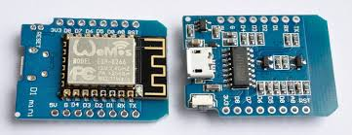](https://nl.aliexpress.com/store/product/ESP8266-ESP12-ESP-12-WeMos-D1-Mini-WIFI-Dev-Kit-Development-Board-NodeMCU-Lua/2130127_32653918483.html?spm=a2g0z.12010608.0.0.248823d4h4167p)

## RGB led strip driver shield

This one is an Open-Smart (P9813 chip)

[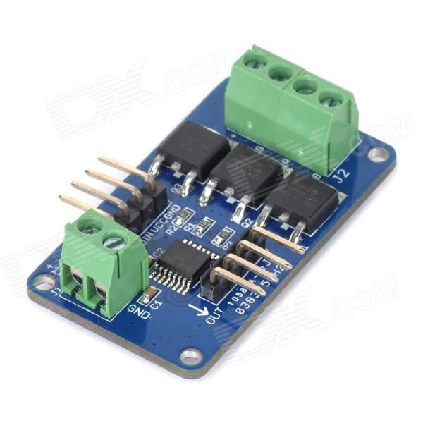](https://nl.aliexpress.com/item/Full-Color-RGB-LED-Strip-Driver-Module-Shield-for-Arduino-UNO-R3-STM32-AVR-12VDC-V1/32830690283.html?spm=a2g0z.search0104.3.1.LUrX9q&ws_ab_test=searchweb0_0,searchweb201602_3_10152_10065_5000015_10151_10344_10068_10345_10342_10343_51102_10340_10341_5130015_10609_10541_10084_10083_10304_10307_10301_10610_5080015_10312_10059_10313_10314_10534_100031_10604_10603_10103_10605_10594_5060015_10142_10107,searchweb201603_32,ppcSwitch_5&algo_expid=14298d3f-6194-4138-9d92-c2274dce36fe-0&algo_pvid=14298d3f-6194-4138-9d92-c2274dce36fe&rmStoreLevelAB=0)

## Mini DC-DC 12-24 V Naar 5 V 3A Step Down Voedingsmodule Buck Converter

Before use trim the output voltage to 5 volt.

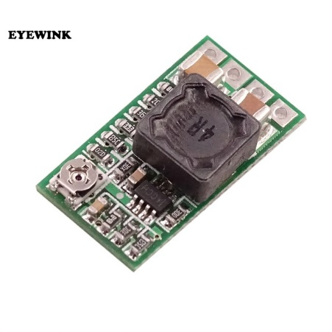

## How to connect

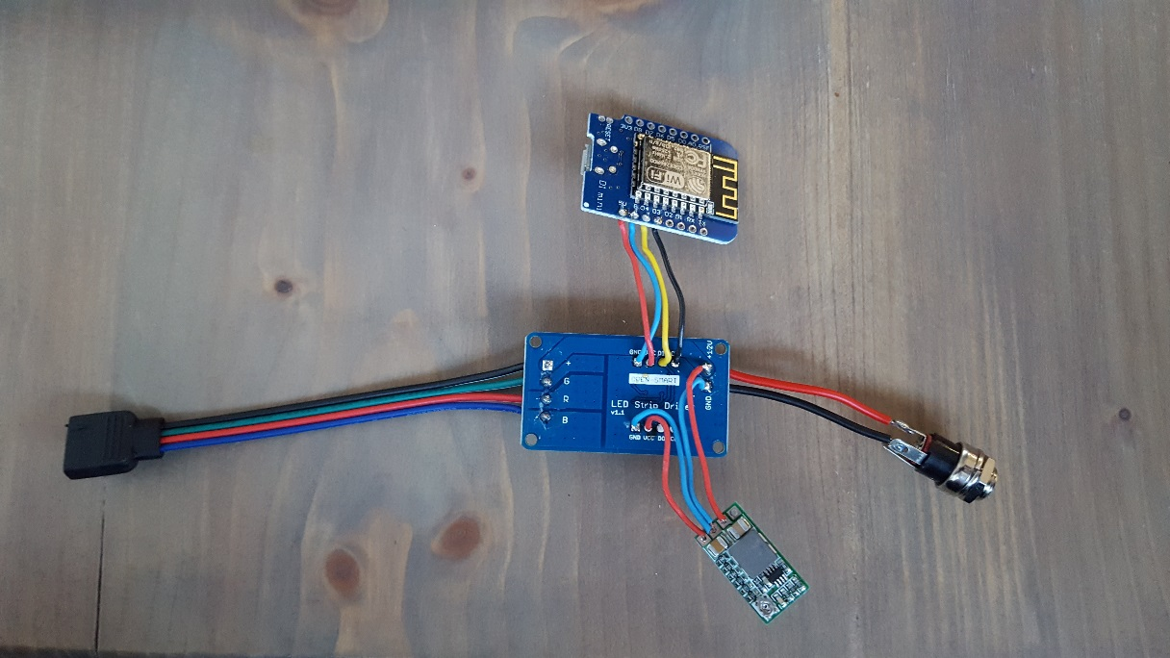 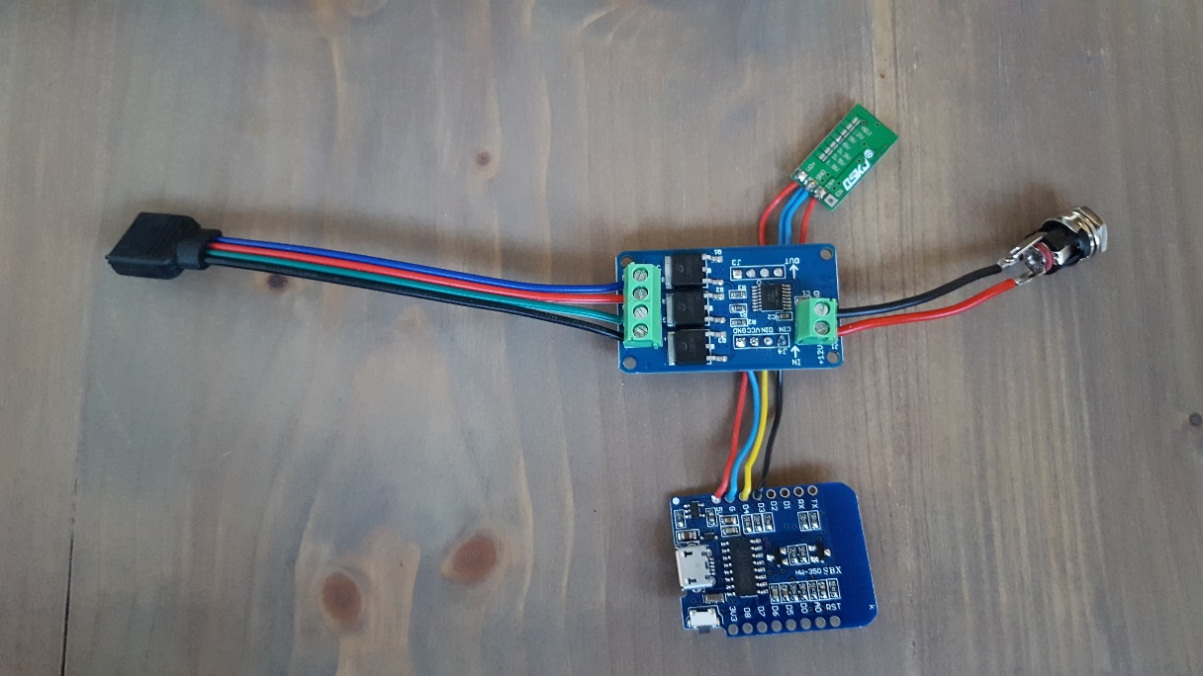

## Put it into the box

<https://www.tinkercad.com/things/8Ej6zM3998g-homeyduino-rgb-driver-box>

